Packet Tracer – Who Hears the Broadcast?

1. Topology

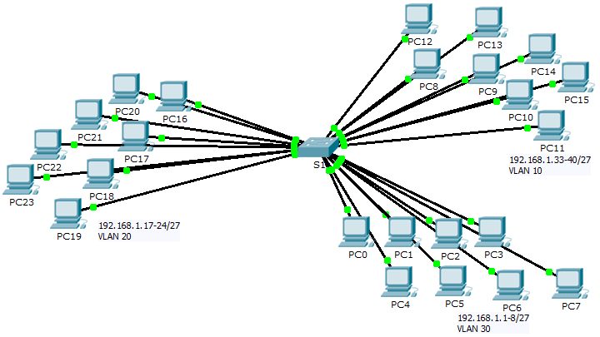

1. Objectives

Part 1: Observe Broadcast Traffic in a VLAN Implementation

Part 2: Complete Review Questions

1. Scenario

In this activity, a 24-port Catalyst 2960 switch is fully populated. All ports are in use. You will observe broadcast traffic in a VLAN implementation and answer some reflection questions.

1. Observe Broadcast Traffic in a VLAN Implementation
   1. Use ping to generate traffic.
      1. Click **PC0** and click the **Desktop** tab> **Command Prompt**.
      2. Enter the **ping 192.168.1.8** command. The ping should succeed.

Unlike a LAN, a VLAN is a broadcast domain created by switches. Using Packet Tracer **Simulation** mode, ping the end devices within their own VLAN. Based on your observation, answer the questions in Step 2.

* 1. Generate and examine broadcast traffic.
     1. Switch to **Simulation** mode.
     2. Click **Edit Filters** in the Simulation Panel. Uncheck the **Show All/None** checkbox. Check the **ICMP** checkbox.
     3. Click the **Add Complex PDU** tool, this is the open envelope icon on the right toolbar.
     4. Float the mouse cursor over the topology and the pointer changes to an envelope with a plus (+) sign.
     5. Click **PC0** to serve as the source for this test message and the **Create Complex PDU** dialog window opens. Enter the following values:
* Destination IP Address: 255.255.255.255 (broadcast address)
* Sequence Number: 1
* One Shot Time: 0

Within the PDU settings, the default for **Select Application:** is PING. What are at least 3 other applications available for use?

**DNS, FINGER, FTP, HTTP, HTTPS, IMAP, NETBIOS, PING, POP3, SFTP, SMTP, SNMP, SSH, TELNET, TFTP, dan lain lain.**

* + 1. Click **Create PDU**. This test broadcast packet now appears in the **Simulation Panel Event List.** It also appears in the PDU List window. It is the first PDU for Scenario 0.
    2. Click **Capture/Forward** twice. What happened to the packet?

**Paket dikirim ke switch kemudian disiarkan ke semua PC yang milik VLAN yang sama dan dalam hal ini, VLAN 10**

* + 1. Repeat this process for **PC8** and **PC16**.

1. Complete Review Questions
   1. If a PC in VLAN 10 sends a broadcast message, which devices receive it? ­­­­­­­­­­­­­­­­**Semua perangkat akhir pada VLAN 10**
   2. If a PC in VLAN 20 sends a broadcast message devices receive it? ­­­­­­­­­­­­­­­­**Semua perangkat akhir pada VLAN 20**
   3. If a PC in VLAN 30 sends a broadcast message devices receive it? ­­­­­­­­­­­­­­­­**Semua perangkat akhir pada VLAN 30**
   4. What happens to a frame sent from a PC in VLAN 10 to a PC in VLAN 30?

**Itu akan di drop karena mereka tidak berada pada VLAN yang sama**

* 1. Which ports on the switch light up if a PC connected to port 11 sends a unicast message to a PC connected to port 13? ­­­­­­­­­­­­­­­­**Port 11 dan 13 akan menyala**
  2. Which ports on the switch light if a PC connected to port 2 sends a unicast message to a PC connected to port 23? ­­­­­­­­­­­­­­­­**Paket akan di jatuhkan**
  3. In terms of ports, what are the collision domains on the switch?

**Setiap port adalah tabrakan domain sendiri**

* 1. In terms of ports, what are the broadcast domains on the switch?

**Setiap VLAN adalah domain siarannya sendiri**

1. Suggested Scoring Rubric

There are 10 questions worth 10 points each.